POETRY

In addition to the above, there will be additional poetry units that will be taught during each school’s Poetry Weeks (2 per academic year). We know that teaching poetry is essential for fostering a deep understanding and appreciation of language, literature and creative expression. By incorporating both contemporary and classic poetry over the course of the year, we aim to develop pupil’s language skills, enhance their cultural awareness and foster creativity. At Broadmeadow, in KS2, we use our Guided Reading sessions to study these poems.

 | YEAR 1 | YEAR 2 | YEAR 3 | YEAR 4 | YEAR 5 | YEAR 6
CLASSIC POETRY | Classic Poetry  What is Pink?  Christina Rossetti  ￼  Autumn 1 | Classic Poetry  Daddy Fell into the Pond  Alfred Noyes  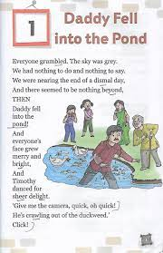 | Classic Poetry  Adventures of Isabel  Ogden Nash  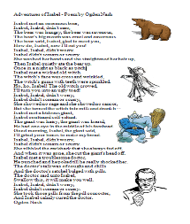﷟ | Classic Poetry  Windy Nights by Robert  Louis Stevenson  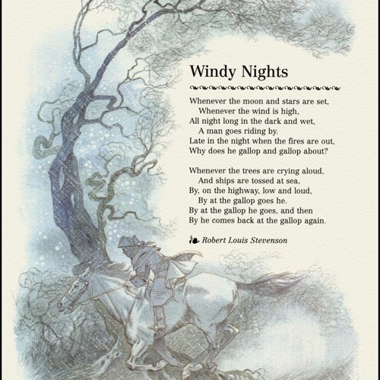 | Classic Poetry  The Listeners  Walter de la Mare  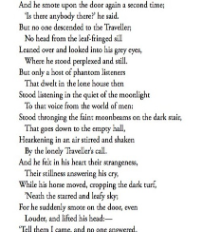 | Classic Poetry  Charge of the Light Brigade  Alfred Tennyson  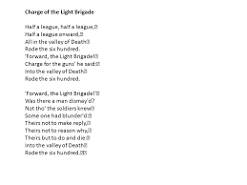
CONTEMPORARY POETRY | Contemporary Poetry  Zim Zam Zoom  James Carter  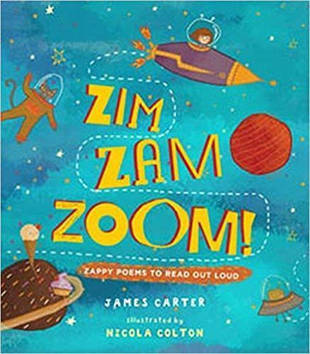  Autumn 2 | Contemporary Poetry  The Dragon with a Big Nose  Kathy Henderson  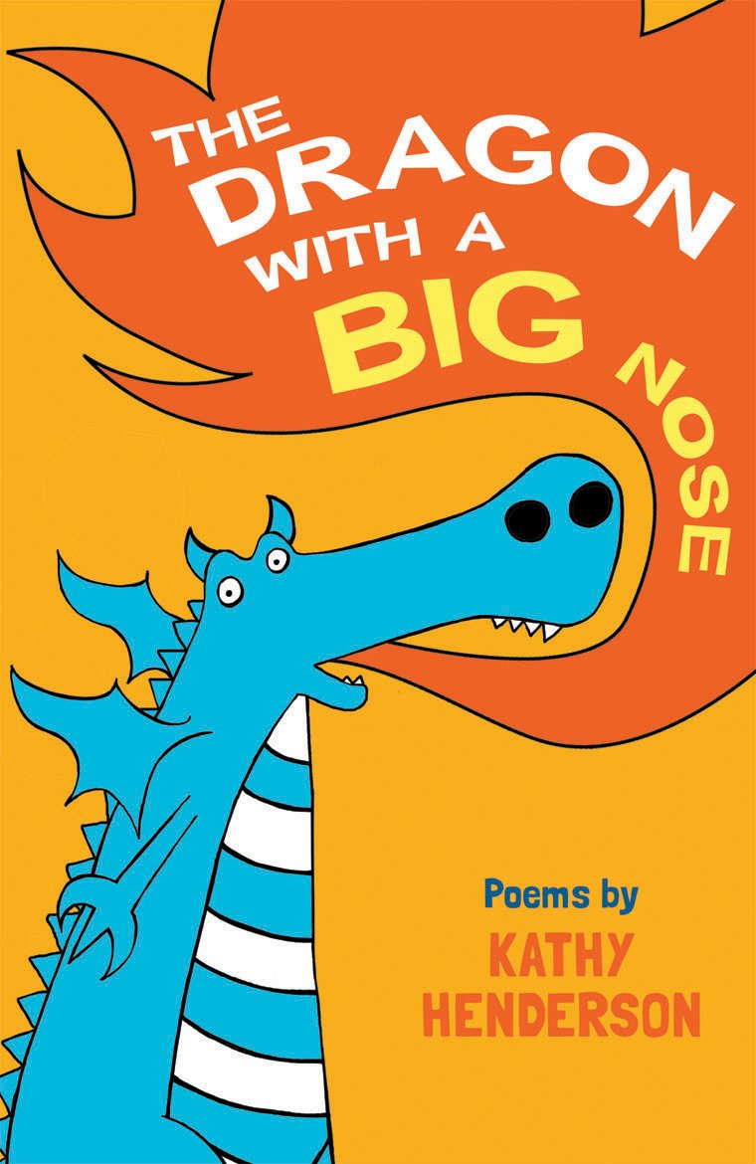 | Contemporary Poetry  A Kid in my Class  Rachel Rooney  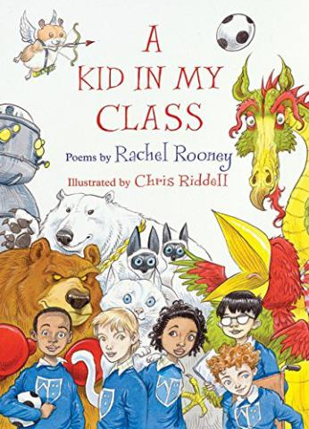 | Contemporary Poetry  Hot Like Fire: Sandwich  Valerie Bloom  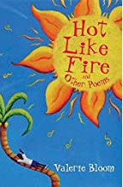 | Contemporary Poetry  Moon Juice  Kate Wakeling  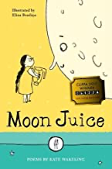 | Contemporary Poetry  Benjamin Zephaniah  The British  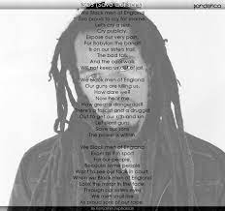

YEAR 1 | 1 | 2 | 3 | 4
AUTUMN | Traditional Tales  The Three Billy Goats Gruff  Ladybird First Favourite Tales  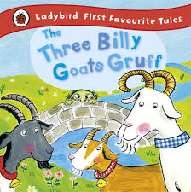 | Modern Stories  Lost and Found  Oliver Jeffers  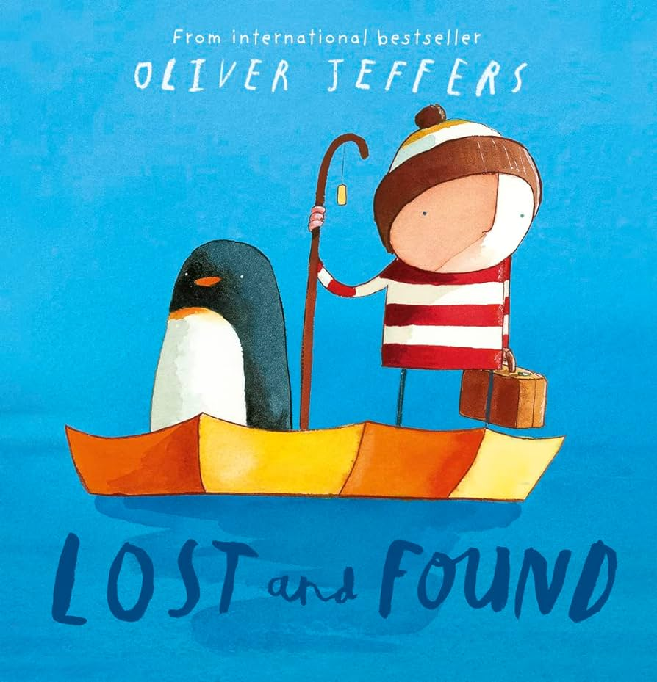 | Classic Stories  Peace at Last  Jill Murphy  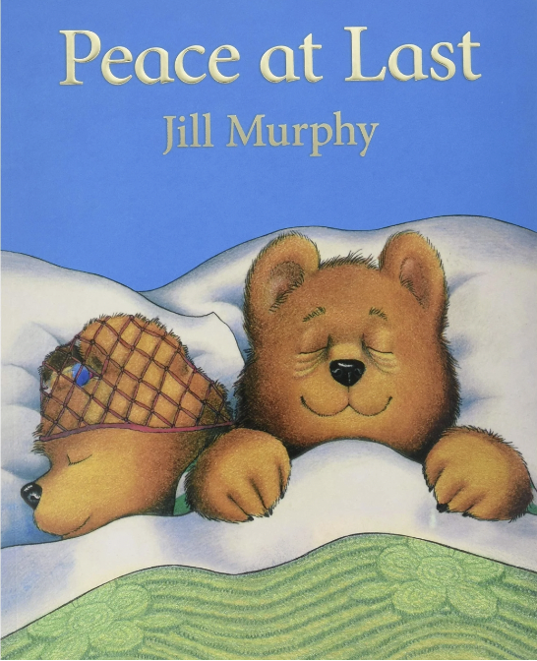 | Classic Stories  Mrs Armitage on Wheels  Quentin Blake  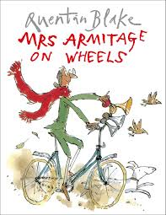
MODEL | Oral retelling of The Three Billy Goats Gruff | Simple sentences describing the places the boy and penguin visited | Shortened version of the story | Sentences about a bike
SUGGESTED  OUTCOMES | Retell the Story  Orally retell the important events from the story | Writing to Describe  Write dictated captions/sentences describing places the boy and penguin visited and could visit (using words containing the taught GPCs) | Retell the Story  Orally retell the events from the story in order/Write the events from the story in order | Writing to Inform  Write dictated sentences about a bike (using words containing the taught GPCs)
SPRING | Classic Stories  The Gruffalo  Julia Donaldson  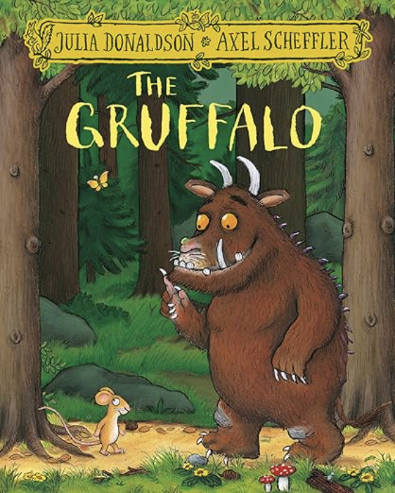 | Non-fiction  Children’s First Cookbook  Annabel Karmel  ￼ | Traditional Tales  The Gingerbread Man  Ladybird First Favourite Tales  ￼ | Modern Stories  If all the world were…  Joseph Coelho  ￼
MODEL | Character description of the Gruffalo | Instructions for making a Gingerbread Man | Shortened version of the Gingerbread Man | A recount of a day out with Grandad
SUGGESTED  OUTCOMES | Writing to Describe  Character profile of their own creature | Writing to Instruct  Instructions for a making a sandwich | Writing to Entertain  Write a short story about the ___ Man | Writing to Recount  Recount of a local walk
SUMMER | Traditional Tales  Robin Hood  Bethan Woollvin  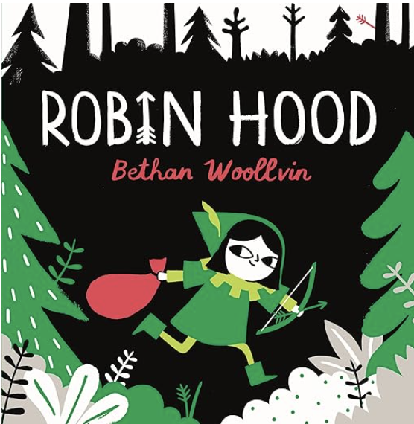 | Non-Fiction  Can We Really Help the Bees?  Katie Daynes  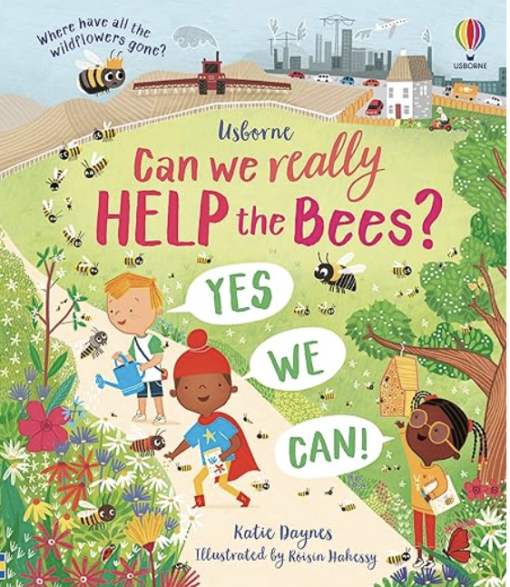 | Modern Stories  Supertato  Paul Linnet and Sue Hendra  ￼ | Modern Stories  Look Up!  Nathan Bryan  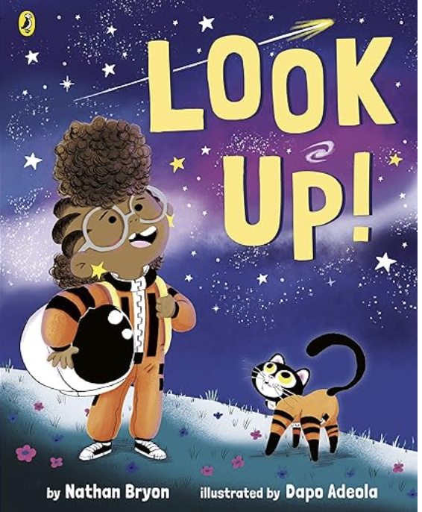
MODEL | A setting description of the Sheriff’s castle | A non-chronological report about Leafcutter Bees | Shortened/simplified version of Supertato | A recount of Rocket’s meteor shower experience
SUGGESTED  OUTCOMES | Writing to Describe  A setting description of the forest | Writing to Inform  A non-chronological report about Honeybees | Writing to Entertain  Write a good vs bad superhero story featuring their own hero | Writing to Recount  Recount of school trip/transition day/sports day

YEAR 2 | 1 | 2 | 3 | 4
AUTUMN | Grammarsaurus  The Place Value of Punctuation  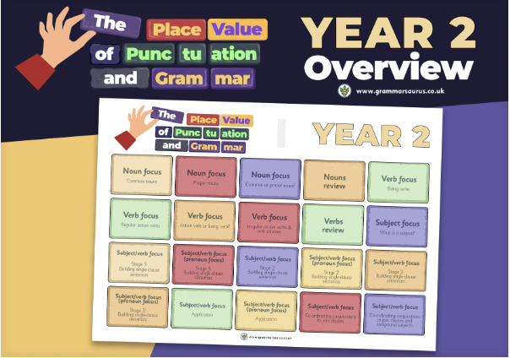 | Modern Stories  Billy and the Beast  Nadia Shareen   | Non-Fiction  Look Inside London  Jonathan Melmoth  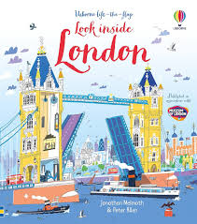 | Classic Stories  Paddington at the Palace  Michael Bond  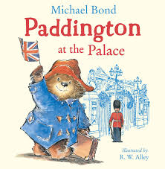
MODEL |  | Character description of Billy | First person recount of a visit to London | Simplified version of Paddington at the Palace
SUGGESTED  OUTCOMES | Short burst piece | Writing to Describe  Character description of the beast | Writing to Recount  Recount of a recent school event | Writing to Entertain  Simple adventure story for  Paddington (based in London)
SPRING | Modern Stories  Snail and the Whale  Julia Donaldson  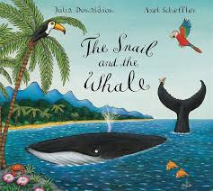 |  | Non-fiction  Big Book of the Blue  Yuval Zommer  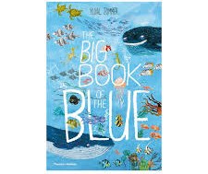 | Traditional Tales- TBC
MODEL | Setting description of the frozen land | Recount of when the snail met the whale and set off | Non-chronological report about sharks | A shortened version of the story
SUGGESTED  OUTCOMES | Writing to Describe  A setting description of a location from the book | Writing to Recount  Recount of when the whale got stranded | Writing to Inform  A non-chronological report about an ocean animal of choice | Writing to Entertain  Write their own version changing the setting
SUMMER | Classic Stories  The Hodgeheg Dick King-Smith  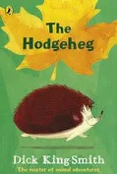 |  | Non-fiction  Info Buzz India  Izzi Howell   | Traditional Tales  Pattan’s Pumpkin  Chitra Soundar  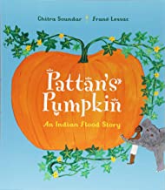
MODEL | Setting description of the dangerous road | Recount of Max’s adventure to the park | How to Make Pumpkin Soup | Simplified version of Pattan’s Pumpkin
SUGGESTED  OUTCOMES | Writing to Describe  Setting description of the park | Writing to Recount  Recount of a trip to the local park | Writing to Instruct  How to make chapatis | Writing to Entertain  Write their own traditional tale

YEAR 3 | 1 | 2 | 3 | 4
AUTUMN | Grammarsaurus  The Place Value of Punctuation  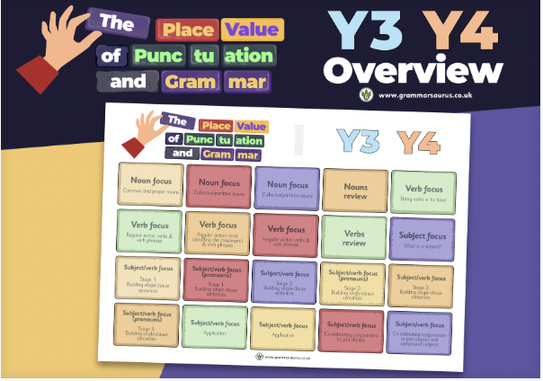 | The Sheep Pig  Dick King Smith   | The Proudest Blue  Ibtihaj Muhammad and S.K. Ali   | Non-fiction  Look Inside Volcanoes and Earthquakes - Emily Bone and Laura Cowan  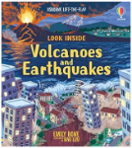
MODEL |  | Narrative - story about a farm disaster (cow?) | Character Description of teh bully | Non-chronological report about earthquakes
SUGGESTED  OUTCOMES | Short burst piece | Writing to Entertain  Narrative - story about a farm disaster (sheep?) | Writing to Describe  Character Description- Brave Asiya | Writing to Inform  Non-chronological report about volcanoes
SPRING | Classic Stories  The Iron Man  Ted Hughes  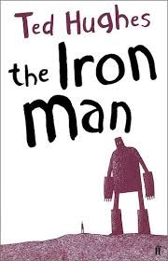 |  | The Pebble in my Pocket - Meredith Hooper  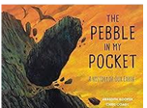
MODEL | A narrative description – top of the cliff | How to catch the giant in Jack and the Beanstalk | Volcano setting description | Information text about soil
SUGGESTED  OUTCOMES | Writing to Entertain  Narrative description of a part of the story - where the giant emerges from the sea | Writing to Instruct  Instructions for catching an iron giant in a trap | Writing to Entertain  Setting description- water/sea/river (eroding pebbles) | Writing to Inform  Information text about rocks (science link)
SUMMER | The Boy Who Grew Dragons - Andy Shepherd  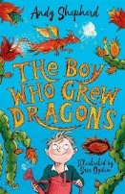 |  | Hansel and Gretel - Anthony Browne  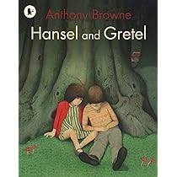 | Powered by Plants - Clive Gifford  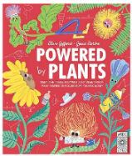
MODEL | Persuasive letter to Mr Henry (Basilisk) | Character description of Toothless | Abridged version of story | Setting description of the dark woods/campsite
SUGGESTED  OUTCOMES | Writing to Persuade  Persuasive letter - a dragon as a school pet | Writing to Describe  Character description of Flicker the Dragon | Writing to Entertain  Own fairytale based on H&G | Writing to Inform  Non-chronological report about Blackwell Village

YEAR 4 | 1 | 2 | 3 | 4
AUTUMN | Grammarsaurus  The Place Value of Punctuation  Firework Maker’s Daughter - Phillip Pullman  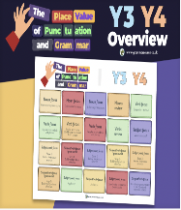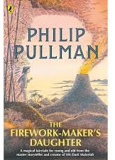 | Firework Maker’s Daughter - Phillip Pullman | Voices in the Park - Anthony Browne  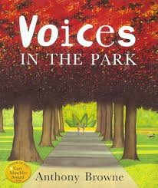
MODEL |  | Model: Halloween  Shared: Bonfires | A finding tale - mysterious object found in the playground | A letter against the skate park
SUGGESTED  OUTCOMES | Writing to Describe  Short burst piece- Setting description | Writing to Inform  Context Fireworks (possibly include History, Guy Fawkes, safety, how they work, when they are used etc) | Writing to Entertain  A finding tale - mysterious object found at the park | Writing to Persuade  A letter against park closure
SPRING | Charlotte’s Web - E.B White   |  | Roman Soldier – Discover the World of the Ancient Roman Army – Tegen Evans and Tom Froese  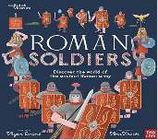
MODEL | A different character from the book | Writing from another point of view | A day in the life of a modern soldier | Non-chronological report about Roman Soldiers/ Britain
SUGGESTED  OUTCOMES | Writing to Describe  Character description of a character from the story | Writing to Entertain  Writing from another point of view  You must be up to the correct point in the book | Writing to Recount  Diary of a day in the life of a Roman soldier. | Writing to Inform  Non-chronological report about Roman Soldiers/ Britain
SUMMER | Varjak Paw - S.F Said  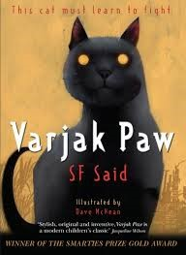 |  | Non-fiction  Rivers: An Incredible Journey  from Source to Sea  Simon Chapman  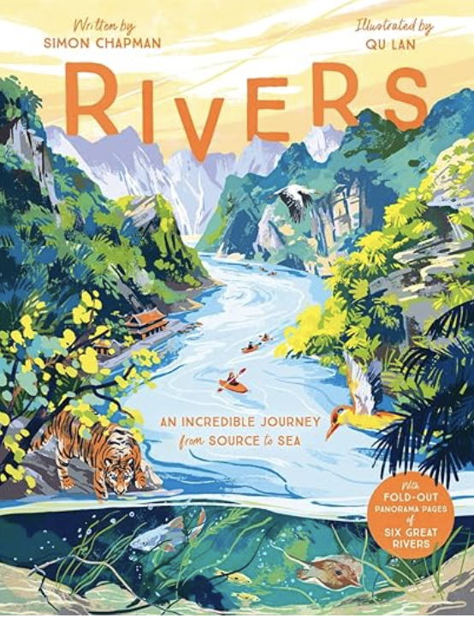 | Traditional Tales  A Tale Dark and Grimm  Adam Gitwitz  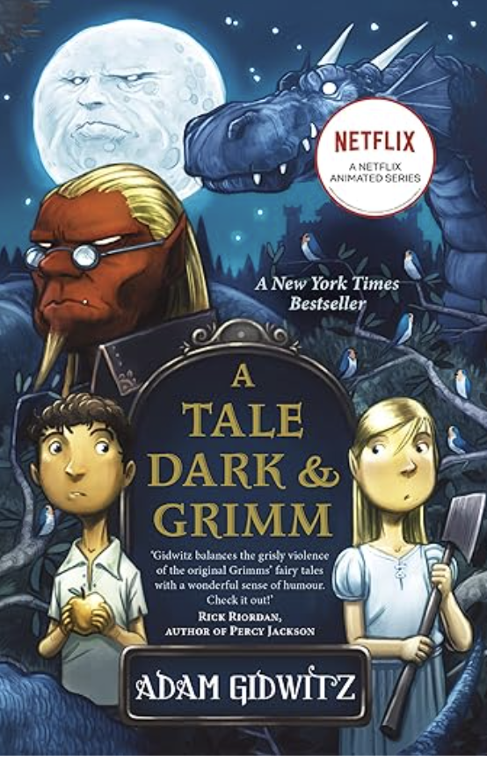
MODEL | A diary of a journey | Writing to Entertain  Varjak’s first encounter with the city dogs from his perspective | A non-chronological report on the River Severn | Setting description of the castle dungeon
SUGGESTED  OUTCOMES | Writing to Recount  A dairy of the journey of one of the cats | Writing to Entertain  Varjak’s first encounter with... | Writing to Inform  A non-chronological report on a great river (Amazon, Ganges, etc.) | Writing to Describe  Setting description of the Witch’s Lair

YEAR 5 | 1 | 2 | 3 | 4
AUTUMN | Grammarsaurus  The Place Value of Punctuation  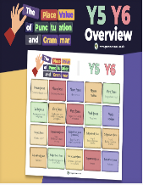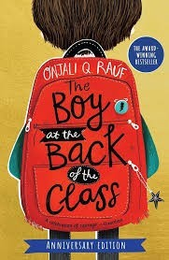 | The Boy at the Back of the Class - Onjali Q Rauf | The Nowhere Emporium- Ross Mckenzie  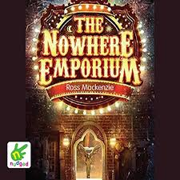
MODEL |  | Non-chronological report about Baghdad | Setting description of own Emporium
SUGGESTED  OUTCOMES | Short burst piece- Diary entry of a character from Boy at the back of the Class | Writing to Inform  Non-chronological report about Birmingham/Baghdad | Writing to Describe  Setting description of own Emporium
SPRING | Tuesday - David Wiesner  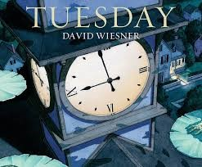 |  | The House with Chicken Legs - Sophie Anderson  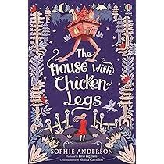
MODEL | Description from someone's POV | Overtaking story | A letter asking mum/teacher to do something | Writing to inform- Stately homes? Visit a local one?
SUGGESTED  OUTCOMES | Writing to Describe  Description from someone's POV | Writing to Entertain  Narrative- Overtaking, change frogs to another animal/school not village | Writing to Persuade  Letter asking Baba to make the house stay in one place | Writing to Inform  Information leaflet about the house: history, magical power, what it is made of, who visits, how to care for it)
SUMMER | Holes - Louis Sachar  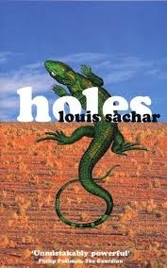
MODEL | An abridged version of a section of the story (arrival at camp) | A letter to mum about a trip | A non-chron about a fictional animal | Balanced argument - should children be given treats for their birthday?
SUGGESTED  OUTCOMES | Writing to Entertain  Devise a new place that Stanley is sent to- Tech Free, Strict/ OTT behaviour | Writing to Recount  Informal letter home to mum telling her all about the camp (pretending all is well) | Writing to Inform  A non-chron report about yellow-spotted lizards | Writing to Inform  Balanced argument - should children be sent to camp as punishment?

YEAR 6
AUTUMN
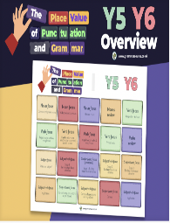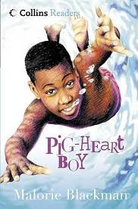
PIG HEART BOY - Malorie Blackman
Genre/Outcome: Setting description - Fairground  Register: Informal  Model Text: Chapter 1  Purpose: To entertain | Genre/Outcome: Letter  Register: Formal  Model Text: To persuade... disco  Purpose: To persuade... theme park | Genre/Outcome: Diary entry after operation  Register: Informal  Model Text: Diary entry as Cameron  Purpose: To inform/recount
Genre/Outcome: Non-chronological report – rainforest  Register: Formal  Model Text: Non-chronological report – Sahara  Purpose: To inform | Genre/Outcome: An adventure narrative  Register: Informal  Model Text: An adventure narrative with different characters  Purpose: To entertain | Sprout adverts if time allows
SPRING
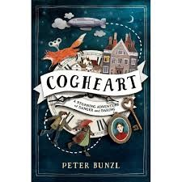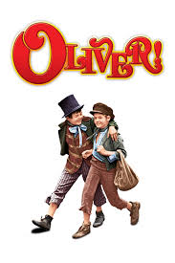
COGHEART - Peter Bunzl
Oliver Twist – Visual Literacy
Genre/Outcome: Character description  Register: Informal  Model Text: Character description of Malkin  Purpose: To entertain | Genre/Outcome: Diary entry (Lilly)  Register: informal but language choices  Model Text: Diary entry (Lilly different part)  Purpose: To inform | Genre/Outcome: Create own chapter  Register: Formal  Model Text: Rewrite of a chapter  Purpose: To persuade
Genre/Outcome: Information text – The Victorians  Register: Informal  Model Text: Information text- Victorians but different aspects  Purpose: To inform | Genre/Outcome: Balanced argument – Workhouses  Register: Formal  Model Text: Balances argument- Working Children  Purpose: To inform
SUMMER
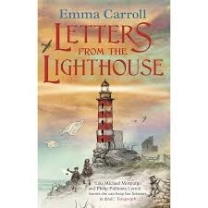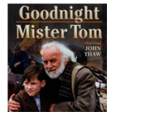
Letters from the Lighthouse - Emma Carroll Goodnight Mr Tom – Visual Literacy
Genre/Outcome: Speech (As Churchill – take in an evacuee)  Register: Formal  Model Text: Speech (As Churchill – Support the war effort)  Purpose: To persuade | Genre/Outcome: Information/Explanation text – How to take care of an evacuee/How to be the best evacuee  Register: Formal  Model Text: How to Stay Safe During an Air Raid  Purpose: To inform/explain | Genre/Outcome: To inform  Register: Formal  Model Text: A letter of complaint- Holiday from Hell  Purpose: To entertain
Year 6 End of Year Production

